**Lab 02**

1. Select one of the routers. Apply FIFO for packet scheduling. Produce graphs for the drop probability for different traffic classes in the same figure.

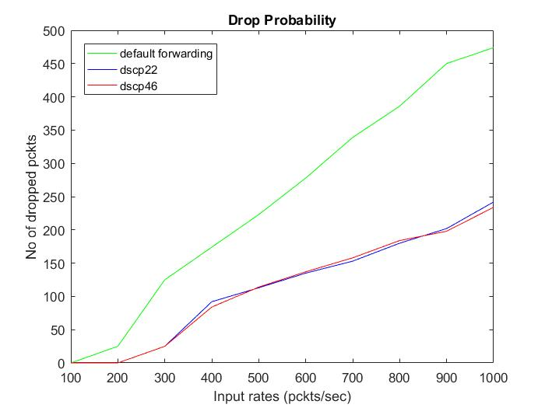

1. Now change the scheduling algorithm to Fair Queuing and obtain the same graph.

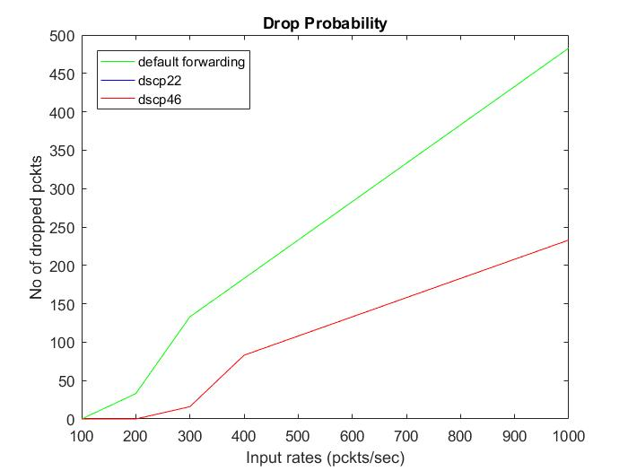

1. Finally, change the scheduling algorithm to WFQ and observe the drop probability against packet-in rate.

Weight of the queues -:

Default = 10%

DSCP-22 = 30%

S+DSCP-46 = 60%

